**Ranking Lego by number of pieces**

The Quinn family owns a lot of Lego. Below is just a small selection of the Lego in the house. We need you to number them in order from the least to the most pieces.

9 X-wing Fighter

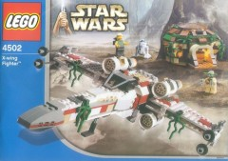

8 Naboo Starfighter

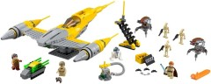

12 Sail Barge

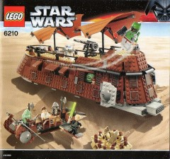

20 Millenium Falcon

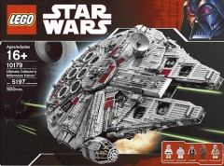

19 Star Destroyer

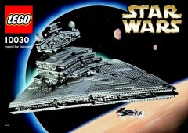

11 Kylo Ren’s Tie Fighter

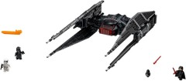

13 AT-ST

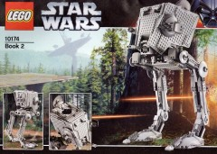

7 ARC170

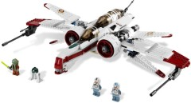

15 Republic Gunship

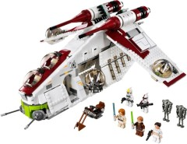

17 Blockade Runner

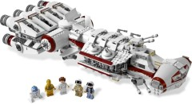

18 R2-D2

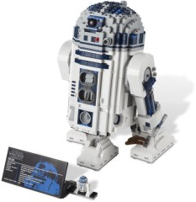

14 BB8

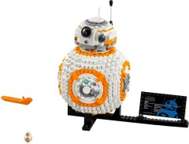

16 First Order Walker

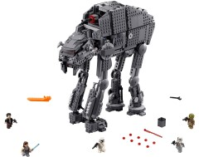

6 First Order AT-ST

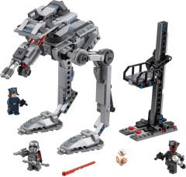

5 Yoda’s Hut

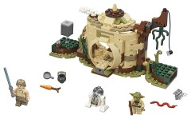

3 Unikitty Cloud Car

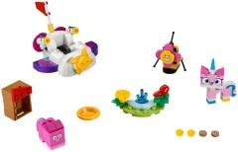

10 The Batmobile

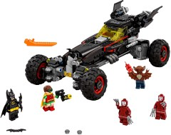

2 Spiderman Spider Truck Adventure

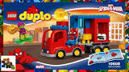

1 Jurassic World – Gentle Giants Petting Zoo

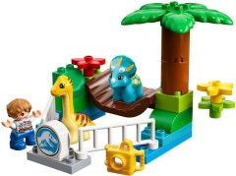

4 Thunder Hollow Crazy 8 Race

